Q1.
D. orders.forEach(order -> { ... });
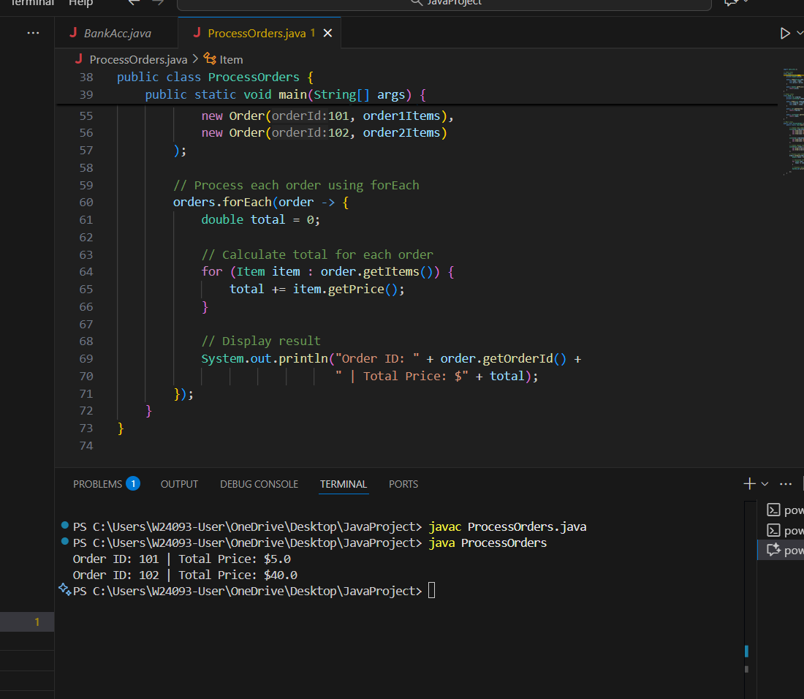

Since orders is a collection (List), you can use forEach() to iterate over each element.

It is a modern looping method introduced in Java 8.

Unlike traditional for loops, it does not require an index, making the code clean and easy to read.

It performs well when processing large amounts of data.

The other options (A, B, C) either require an Iterator.

Q2.
B. while (!line.isEmpty()) { ... }
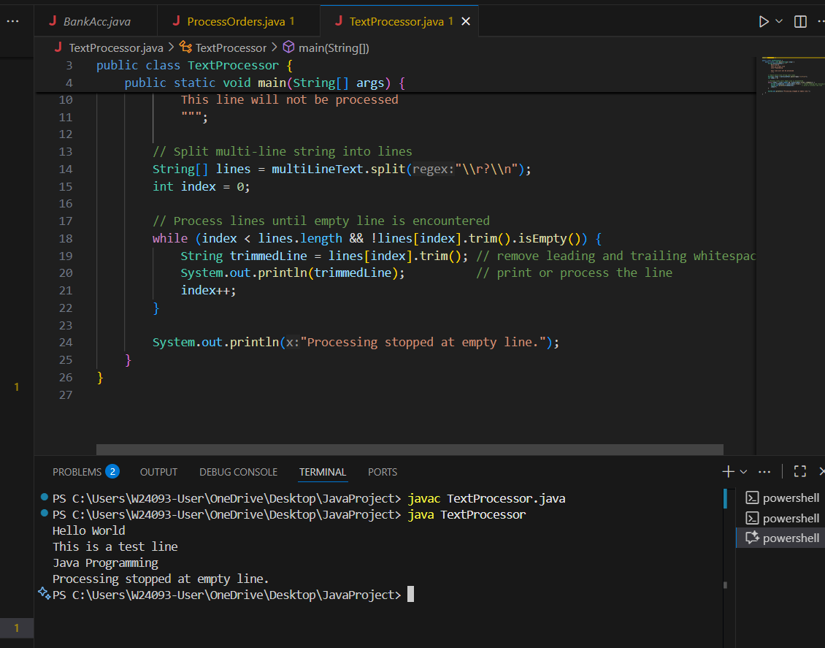

B: Condition is checked before each iteration, so processing stops immediately when an empty line is reached.

A: Iterates over all lines, cannot stop immediately when an empty line is encountered

C: Executes the body at least once even if the first line is empty, which may be unnecessary.

D: Works, but less readable; you have to manually check for empty lines and break the loop.

Q3.
- while (retryCount < 5) { ... }
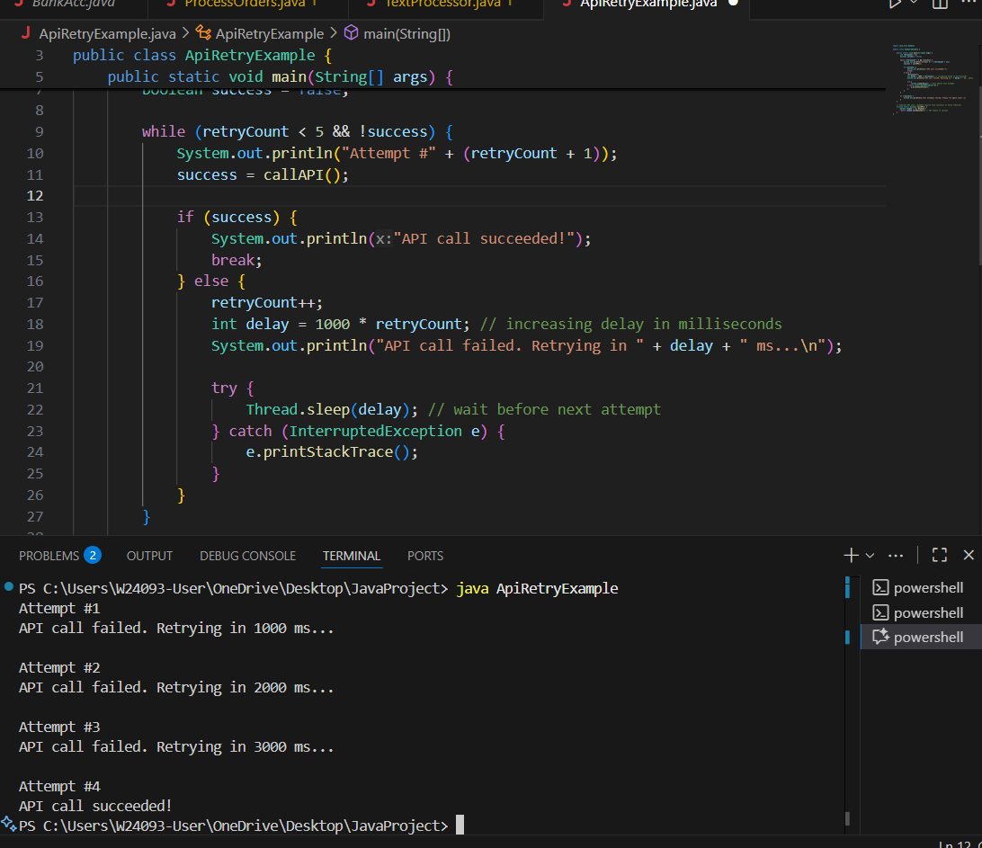

B: Retry API up to 5 times with early exit on success and increasing delays.Pre-condition check, flexible, and supports conditional exit.

A: Works, but less flexible if you want to exit early on success; must use break.

C: Executes the loop at least once, even if the first attempt shouldn’t run.

D: Lambda/stream is not ideal for conditional exit;

Q4.
while (!reachedEdge && !hitObstacle) { ... }
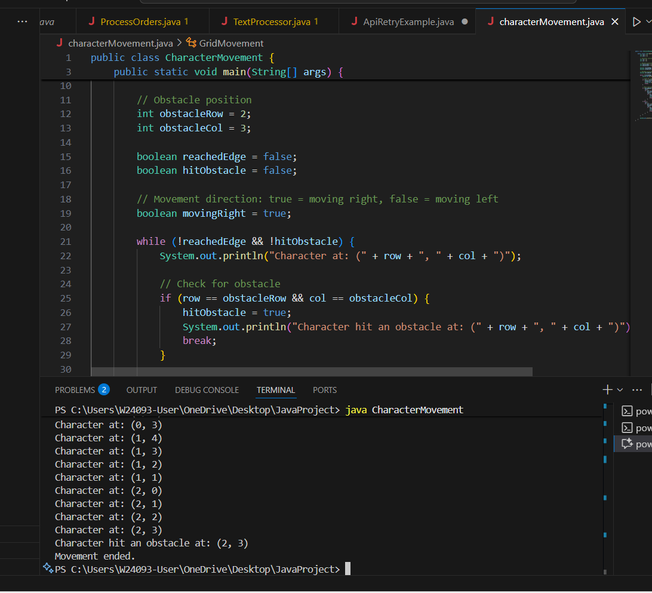

A: Requires a predefined number of steps. Not flexible.

B: Pre-condition check allows dynamic stopping and flexible movement logic

C: Executes at least once, even if the character is already at edge or obstacle

D: Streams iterate over all cells; cannot break early based on dynamic conditions like obstacles.

Q5.
while (low <= high) { ... }
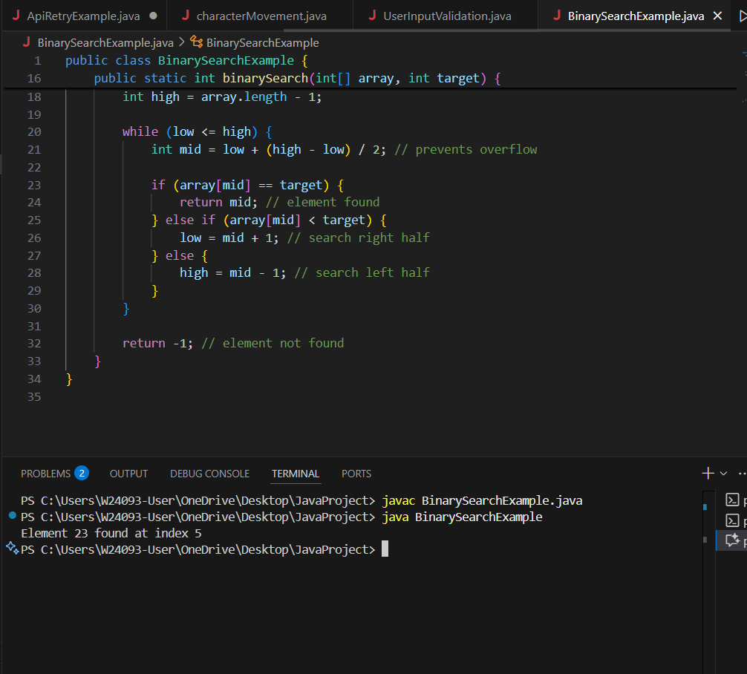

B: most suitable for binary search

C: Incorrect condition

D: linear search, not suitable for binary search

Q6.
- do { ... } while (!isValidInput);
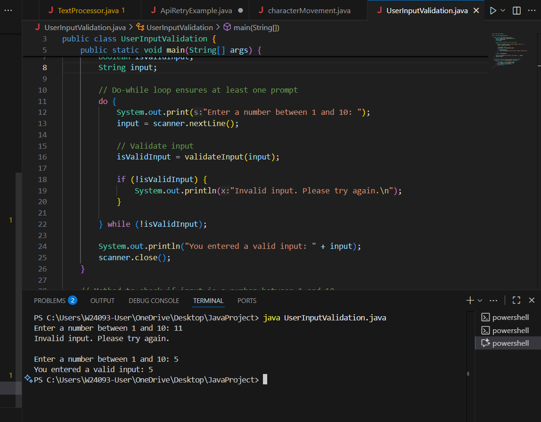

A: Infinite loop; requires explicit break statement when input is valid. Less clean.

B: Ensures at least one prompt, then checks validity, and repeats until input is valid.

C: Condition checked before first iteration.

D: Streams are not designed for interactive input; cannot easily exit on valid input.

Q7.
Answer is B.

B: while (!tasks.isEmpty()) { ... }
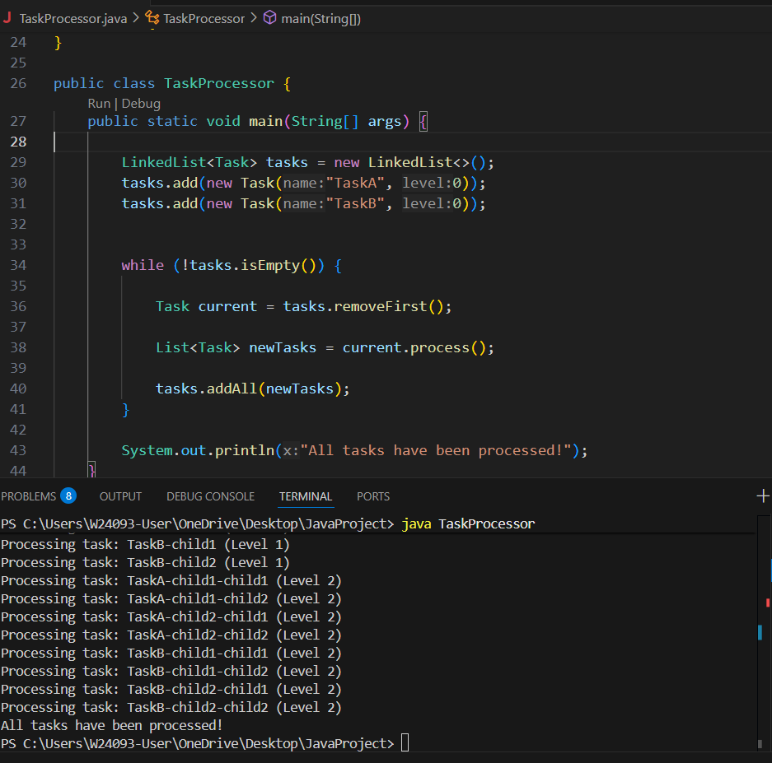

A: Iterates over the list once, ignoring new tasks added during iteration.

C: Similar to B, but executes the loop at least once, even if the list is empty. Risky if the list starts empty.

D: Like A, it’s not safe for modifying the list during iteration. Doesn’t handle dynamic additions.

Q8.
Answer is A.

A: Most readable and efficient
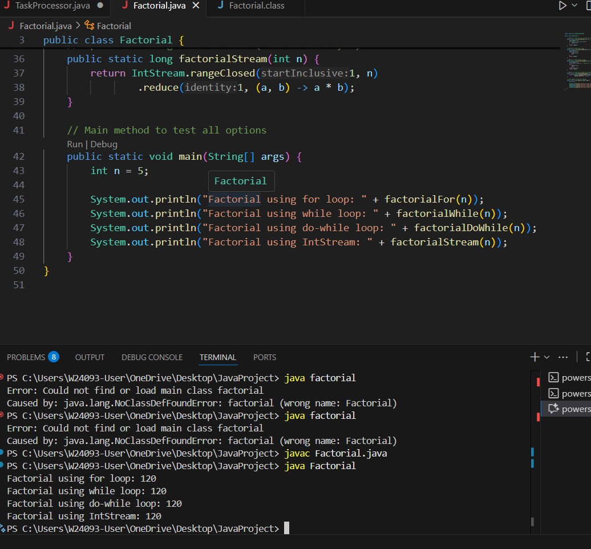

B: Works fine but less efficient.

C: Good for n>0 . Risky if n<0.

D: Morden java code. Less readable for beginners.

